**ATTACHMENT B – Planning Proposal Mapping**

**APPENDIX 1 Existing Zoning Map**

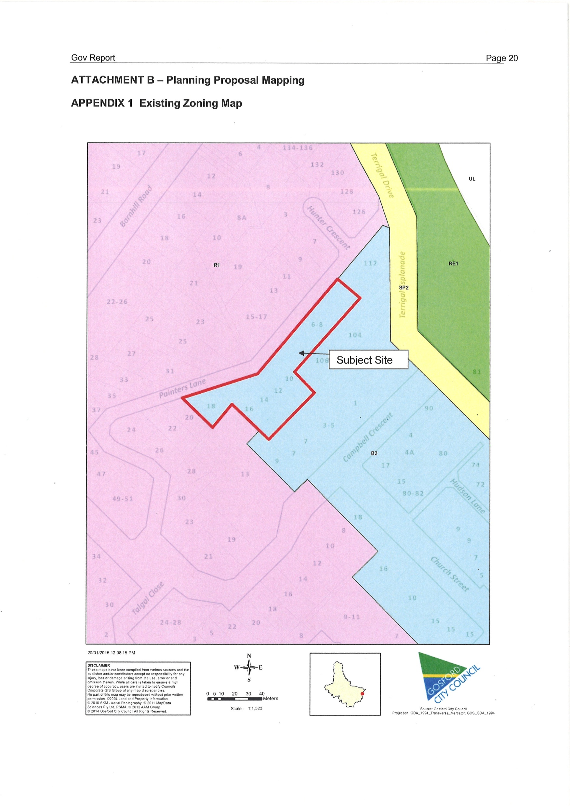

**APPENDIX 2 Height of Building Map - GLEP 2014**

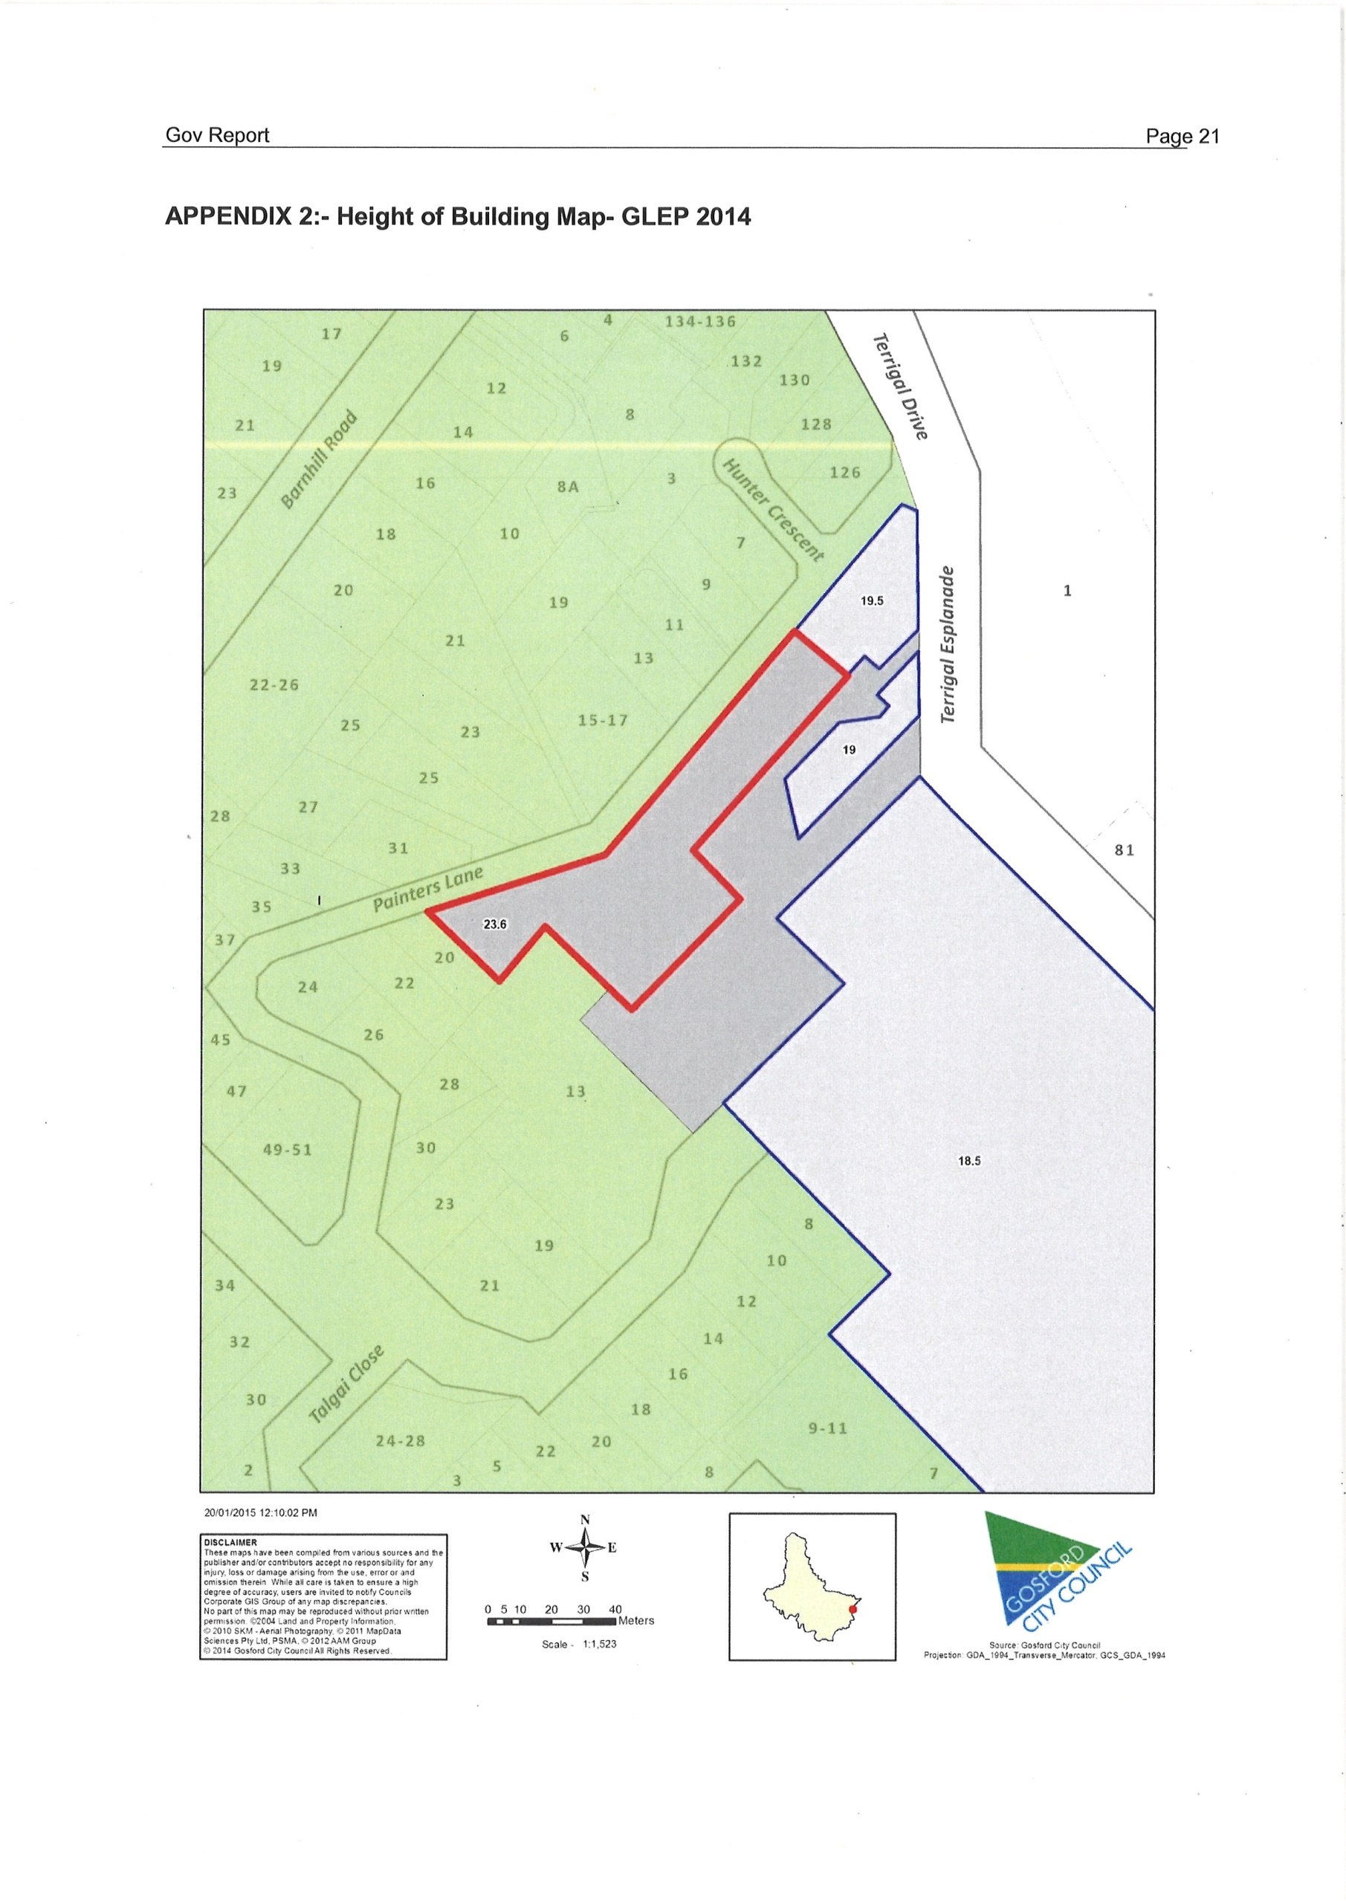

**APPENDIX 3 Proposed Zoning under Draft Gosford LEP**

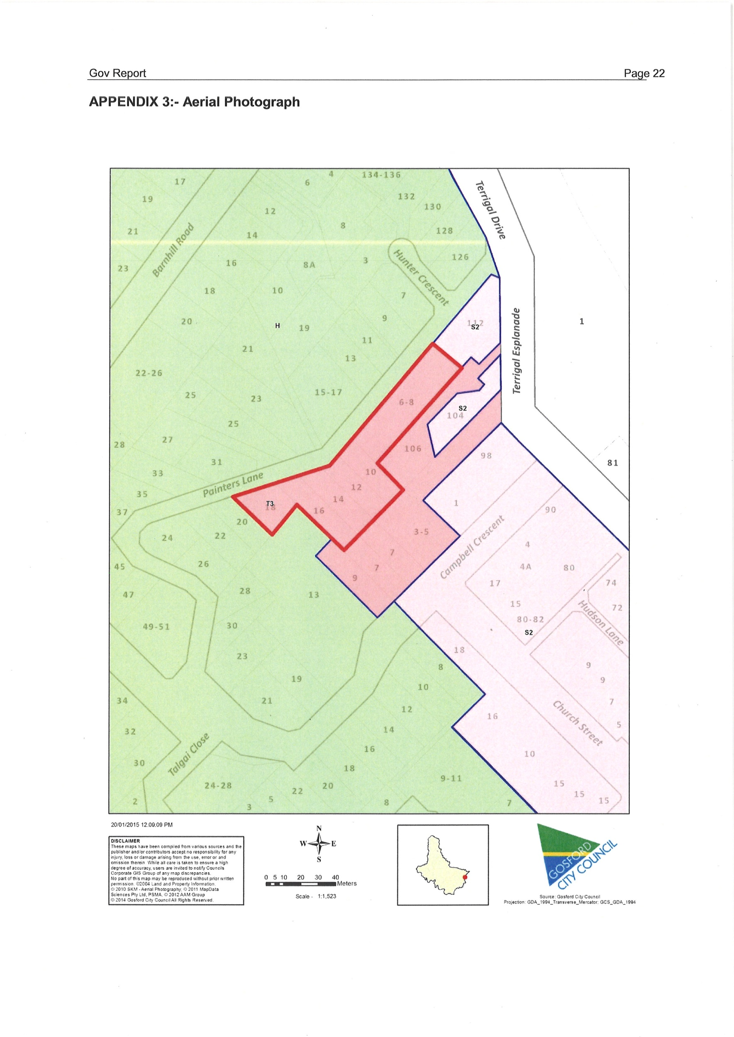

**APPENDIX 4 Aerial Photograph**

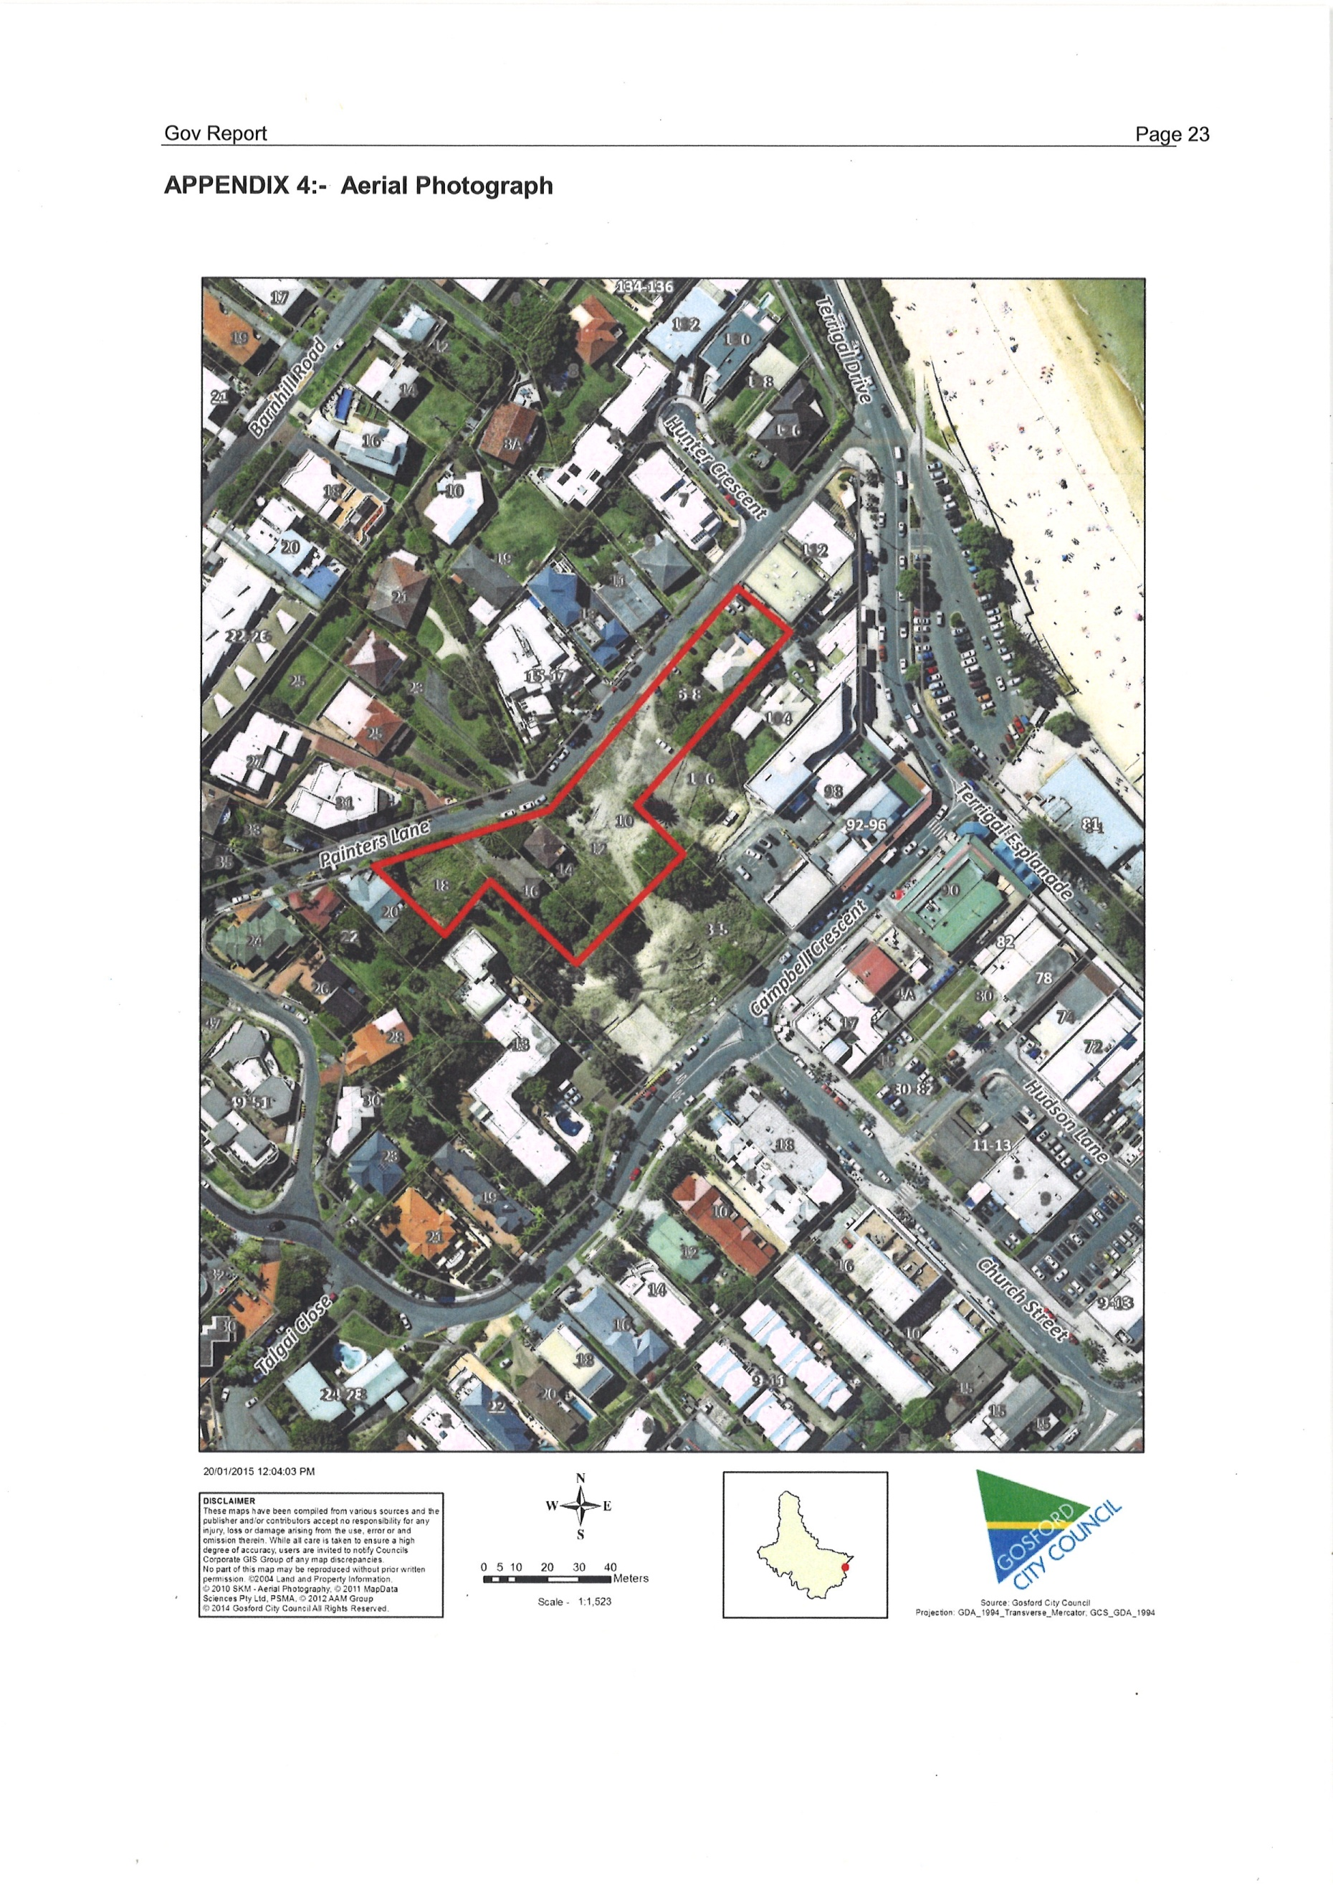

**APPENDIX 5 SEPP 71**

